Phoenix Junior School
Toolkit

Please decide at what level you meet the criteria and then fill in the school evidence box with as much evidence as you see fit to prove that you meet the standard. The guidance and possible evidence box is there to help you, but if you feel there are other ways you can show it then please do include them too. Reference any appendices and attach them to the email.
We have a manageable and appropriate workload
FULLY MET
GUIDANCE  PPA time given on timetables, extra time given for extra responsibilities.  Staff Meetings are held on a Wednesday after school for an hour. Year group meetings are held for an Hour on a Monday after school.  Review of school policies on Assessment and Planning.  To ensure staff concerns are listened and responded to. | POSSIBLE EVIDENCE  Staff meeting timetables  QA Schedule and timetable  School policies  NTW Report. | SCHOOL EVIDENCE  Allocated timetables and staffing structure, giving responsibilities and roles. Subject leaders time allocation.  See Appendix 4.  QA Calendar, whole school calendar.  See Appendix 3.  School Policies are annually presented and feedback from staff incorporated where required. They are available on the website and are located in staffrooms and offices.  See Appendix 5.  NTW Report and highlighted areas and comments shown through meeting notes they have been responded to in line with our school values.  100% of the staff said in the survey that they have someone at work they can speak to for advice, see Nourish Survey.

We value and prioritise staff’s health and understand the need to rest and recharge.
MET
GUIDANCE  Do you have quality facilities for all staff to eat at lunchtimes?  - Is there enough cutlery?  - Is there enough equipment? (Microwaves, stoves etc)  - Are there appropriate tables and chairs to eat effectively?  - Are there a different choice of seats to sit on?  - Do staff get subsided school meals?  Is your staffroom welcoming?  Do you provide refreshments free of charge?  Are there enough toilet facilities for all the staff? | POSSIBLE EVIDENCE  Photographs, NTW Report, Email tail, staff comments. | SCHOOL EVIDENCE  We have three areas in school that staff can prepare drinks and food. Two are designated staff areas for relaxation and children have no access, these are located at different levels of the school for ease of access. The other is a back kitchen that can be used for quickness. See appendix 2.  The main staff room has a washing machine, fridge, dishwasher, cooker, microwave, filtered water and hot water outlets.  The mid staffroom has hot water, fridge, microwave and the back kitchen has a microwave, fridge, hot water and filtered water. Through the NTW report staff rating was 8.9 saying that the staffroom is well equipped, with 8/10 saying it they were welcoming.  Our refreshments are free of charge, including porridge at break time.  If staff eat school dinners with the children or are on duty they get their meals free, this has seen 50% of staff taking this option.  We have four staff toilets around the school and two disabled that can be used by staff.  Staff are not expected to send or receive emails after 6.00pm and weekends or over holidays. All emails have this as a tail message;  As an organisation FPTA Academies encourages its employees to have a strong work life balance. As such, if employees wish to send emails when convenient to them, this is fine, however there is no expectation of anyone to read or respond outside of normal working hours.  Last year all staff (apart from SLT) were given a wellbeing day in the longest term (Autumn) to use for their own benefit.

We have a member of staff in charge of wellbeing who is not on SLT
FULLY MET
GUIDANCE  Is the role set out as part of a job description?  How does the wellbeing Lead feed back to SLT? | POSSIBLE EVIDENCE  Governing Body Minutes  Staff survey data | SCHOOL EVIDENCE  Rebecca Warrener has been appointed who is a teaching member of staff she is also a staff governor on our Welfare Committee.  Rebecca will feed back to SLT/Headteacher/Governors/staff at regular intervals, See appendix 1.

Wellbeing is covered in CPD sessions 3 times a year
DEVELOPING
GUIDANCE  Is wellbeing CPD available to all staff?  Are practical wellbeing strategies introduced?  Is health advice incorporated into CPD?  We have three designated wellbeing sessions planned for the whole staff throughout the year. | POSSIBLE EVIDENCE  Staff meeting agendas  CPD Schedule  VBE report  QA Calendar | SCHOOL EVIDENCE  We offered mindfulness training to all staff of which 15 took part.  Staff have undertaken online Stress awareness training. And all staff are welcome to the Wellbeing twilights.  We are Values Based Education school (accredited in 2018) the Headteacher is an Associate Member of VBE.  Wellbeing is scheduled into our Quality Assurance Calendar three times a year where visitors will be invited to discuss aspects of physical and mental wellbeing, see Appendix 3, external facilitators are invited in from the NHS, Benenden, Ed Phyc etc  All staff have access to Bennenden Health Care, our in-House Counsellor. This is set out in the QA Calendar see Appendix 3.

We operate flexible working strategies
PARTIALLY MET
GUIDANCE  Is there flexible access to school during the holidays?  Does your school offer part time and job share contracts when available?  Are staff allowed (within reason) to attend their own children’s school events? | POSSIBLE EVIDENCE  Staff testimonials  Staff survey data  Staff list with days shown  School policies  Staff letters  Staff release forms | SCHOOL EVIDENCE  Staff are not expected to come into school during holidays (unless it is part of their JD). The school is open at specified times to allow for flexibility.  We have two staff who job share and two staff who work three days a week. We also have two members of staff who have reduced hours to four days a week all to suit their personal situations.  Staff are allowed 3 paid occasions of child supported visits per year, any more are unpaid. The policy of the school is to allow staff to attend children’s events, see Appendix 6.

We implement the Find Fifteen Initiative
FULLY MET
GUIDANCE  How do you encourage staff to ‘Find Fifteen’?  How are lunch and break duties allocated to allow everyone a chance for a proper break?  Do all staff have to attend assemblies? | POSSIBLE EVIDENCE  Duty timetables  Staff testimonials  Staff duty Rota  Assembly rota | SCHOOL EVIDENCE  Staff are encouraged to have non-contact time each day, some choose to have lunch with children for a free school dinner, this will be introduced in September. From the Survey 82% of staff said they get more than 10 mins break at lunchtime.  There is a staff rota produced a reviewed each year.  The find Fifteen will be introduced this year in September.  Not if it is part of their PPA. Assemblies are shared equally amongst all staff.
Staff absence is managed effectively and is as low as possible
FULLY MET
GUIDANCE  What percentage of your budget is spent on supply?  Is there access to free advice and support?  Does your school hold back to work interviews? | POSSIBLE EVIDENCE  Budget data  Data  Staff code of conduct  Back to work interviews notes | SCHOOL EVIDENCE  Minimal is spent on cover, absences are covered by HLTA’s or SLT. Last year the amount spent on cover was £250.00, staff absence across the school was 98%.  Staff have free access to the Counsellor and the trust HR and can contact Bennenden Health Care. 100% staff said they have access to someone they can speak to at work.  Upon return to work staff are to complete a form and have a meeting to discuss absence. After three incidents in 6 months a formal interview is help prior to a meeting with HR as per our policy.

Our staff enjoy working at our school and are happy in their job.
PARTIALLY MET
GUIDANCE  Does your staff survey reflect that?  How long to staff stay (on average) at your school?  How are the issues raised in the report being addressed? | POSSIBLE EVIDENCE  Staff survey data, staff testaments.  Staff leaving data/service breakdown.  Report, evidence of breakdown of issues and how it will be resolved. | SCHOOL EVIDENCE  8/10 of staff feel happy at work based upon the survey and 8.7/10 said they enjoyed their job.  Length of service breakdown shows 95% of staff stay for more than three years.  Staff structure, Code of Conduct, QA Calendar, CPD Schedule. See Appendix 1,2,3,4.  Career advancement is important, over the last three years four staff have qualified at HLTA status.  Three have completed their NQT year, Four have been trained in school to become teachers.

Appendix 1
Phoenix Junior Academy Roles and Responsibilities 2019/20 Term 1
PS | LBL | KH | RW | AA | GL
Teaching and Learning | Year 6 Teacher | Year 6 Teacher | Year 6 teacher | Year 5 Teacher | Year 5 Teacher
Safeguarding (Lead) | Writing across the school | Writing across the school | Numeracy Lead | Computing Lead | Reading Lead Support
Pupil Progress |  |  | Safeguarding | Dep Maths Mastery
Data |  |  | Staff Wellbeing Gov
Timetables |  |  | Prefect Lead | JB | KR
Rotas overview |  |  | PSHCE Support Lead | Year 5 Teacher | Year 5 Teacher
Health and Safety |  |  |  | Science Lead | Art and DT Lead
Attendance
Premises
ICT/Website
Finance
Assessment |  |  | Performance Management and Line Management
DLAC |  |  | PS : SW, EL, AA,JBo,JS,EC, KR, SB, JBa,GL,RW,KH,LB-L,SD,LM,CB,JP.
Staffing |  |  | SW: KM,SL,GV,TH,SG,LP,WT,KW,NF.
PM Organisation and overview |  |  | EL: DH,RN,PE Coaches
Parent Forum
PS/SMT Rota's |  |  | EL Raising Attainment Lead
PS/SB Staff disciplinaries |  |  | i/c KS2 Progress | PE Lead
Staff absence |  |  | Curriculum Lead
Lead on PSHCE |  |  | Cover for part TT
 |  |  | Interventions throughout Yrs 3,4,5,6.
 |  |  | Progress meetings lead | Breakfast Club Lead
All Staff will be responsible with Behaviour Management |  |  | Celebration Assembly Lead | Extra Curricular Clubs Lead
 |  |  | Trust T&L Lead | PIXL Co-Ordinator

Appendix 2
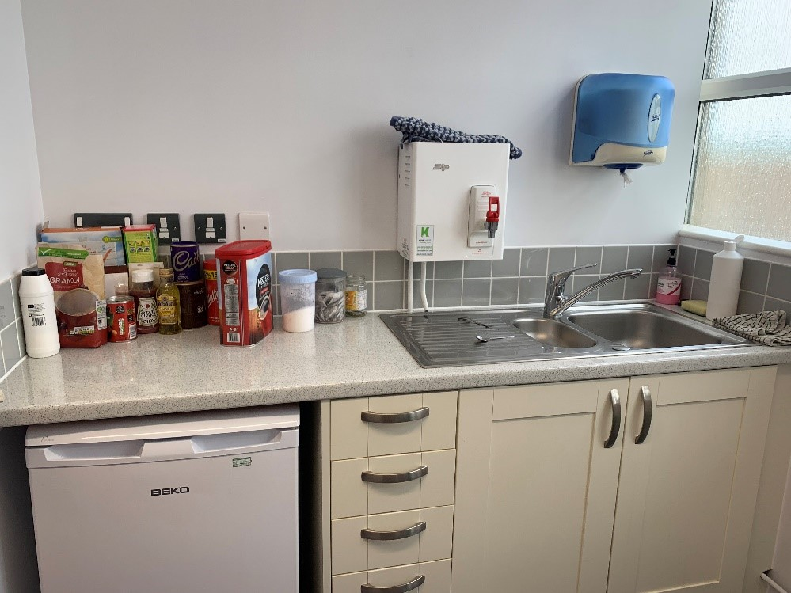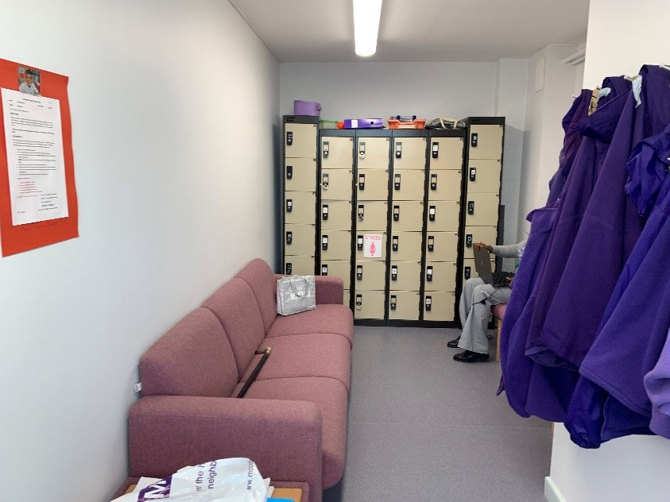
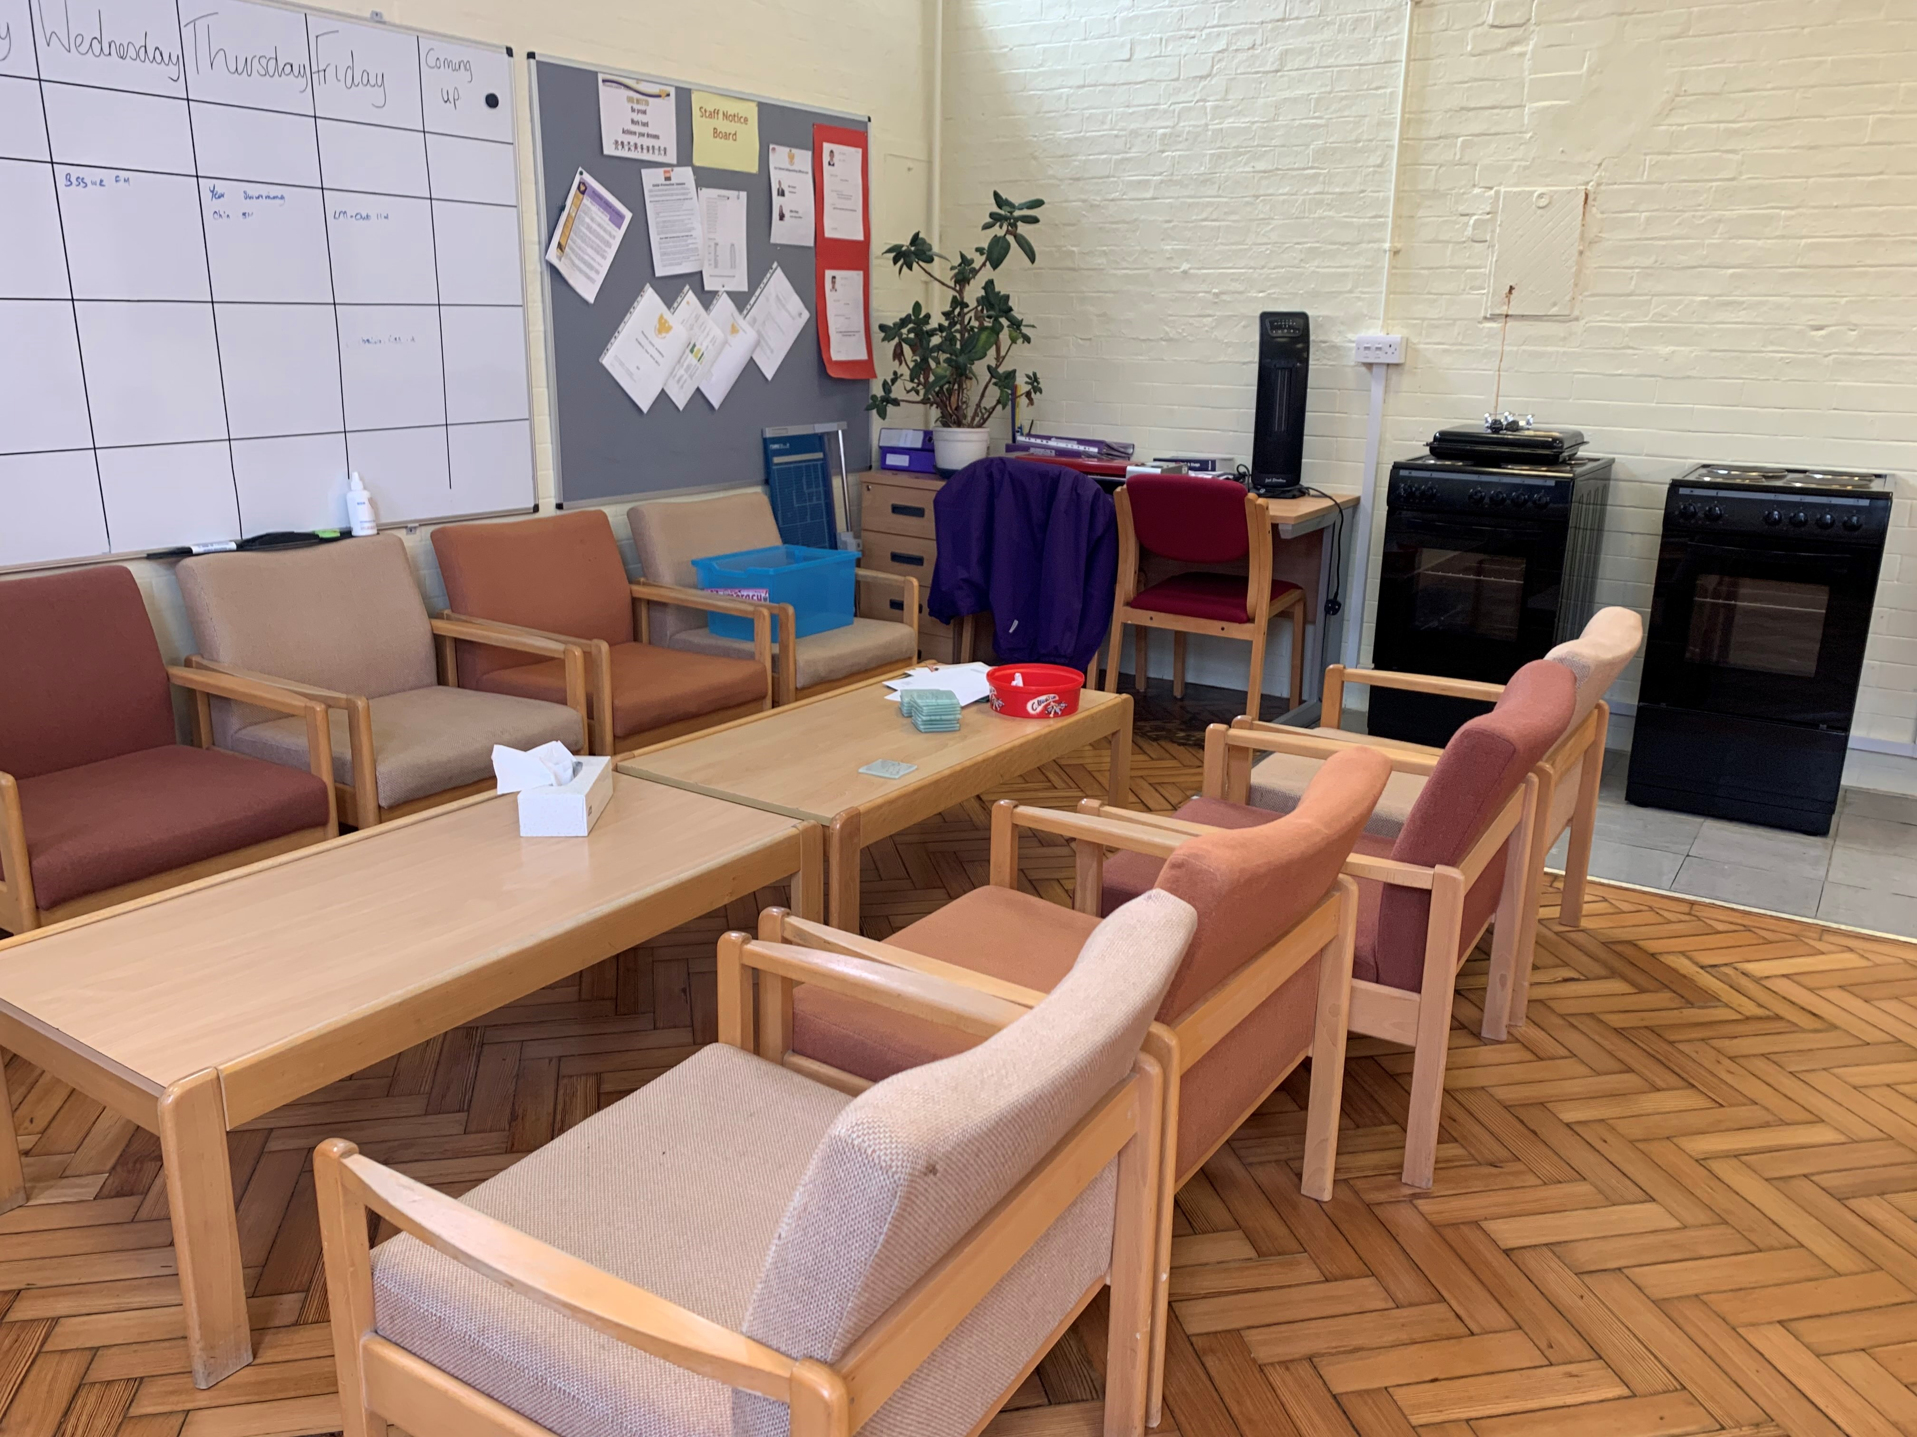
Appendix 3
 | Term 2
Observation Focus: Learning Application/Explanation | Week | Date | Topics |  | Regular Meetings | By | QA Meetings | By
 | 18 | 6th - 10th Jan | Review and update Central Register | PS/SD/DF | SMT Meeting Pastoral Meeting | PS,SW,EL PS,SW,CB,LM | Review of last data capture Review and update Central Register | SLT PS/SD
 |  | Year Meetings | Trips and Visitors for Term 3&4 in Year
 |  | Staff Meeting | Review Staff Structure, Behaviour Policy and SEN. | PS/SW
 | 19 | 13th - 17th Jan | Maths Book look | EL/RW | SMT Meeting | PS,SW,EL | Progress Review Y6 | PS,EL,KH,EBL,RW
 |  | Year Meetings | Reading review and strategy in Year
 |  |  | Parents Evening 3.30-6.00 13th -Y3&4 16th-Y5&6 | ALL STAFF
 |  | Staff Meeting | Writing moderation across school | EL/KH
 | 20 | 20th - 24th Jan | Writing Book look | EL/KH | SMT Meeting Pastoral Meeting | PS,SW,EL PS,SW,CB,LM | Progress Review Y5 | PS,EL,GL,AA,KR/JB
 |  | Year Meetings | Writing Moderation across years
 |  | Staff Meeting | Twilight Session. Wellbeing: strategies to avoid stress | NW/Ed Phyc
 | 21 | 27th - 31st Jan | Science Book look | EL/SW | SMT Meeting | PS,SW,EL | Progress Review Y4 | PS,EL,JBa,EC,LH
 |  | Year Meetings | Interventions update and review-feedback to SW
 |  | Staff Meeting | Staff Wellbeing | PS/RW
 | 22 | 3rd - 7th Feb | Topic Book look ISR (6th) | EL/PS SW | SMT Meeting Pastoral Meeting | PS,SW,EL PS,SW,CB,LM | Progress Review Y3 | PS,EL,JS,SB,KM
 |  | Year Meetings
 |  | Staff Meeting | VBE Update and Review | PS/SW/RW
 | 23 | 10th-14th Feb | Data Input deadline12th Feb |  | SMT Meeting | PS,SW,EL | Progress Review Y6 | PS,EL,KH,EBL,RW
 |  | Year Meetings
 |  | Staff Meeting | Bug Club update and review | EL/JB
Appendix 4
 |  | Monday | Tuesday | Wednesday | Thursday | Friday
 | 8.45-9.00 | Registration
 | 9.00-9.30 | VBE ASSEMBLY
 | 9.30-10.00
 | 10.00-10.40
 | 10.40-11.00 | Break time
 | 11.00-12.15
 | 12.15-1.00 | Lunch time
 | 1.00-1.15 | Year 3 PPA PE/RE Lessons | Year 4 PPA PE/RE Lessons | Year 5 PPA PE/RE Lessons | Management Time PPA | Year 6 PPA PE/RE Lessons
 | 1.15-1.30
 | 1.30-1.45
 | 1.45-2.00
 | 2.00-2.15
 | 2.15-2.30
 | 2.30-2.45 |  |  |  | CELEBRATION ASSEMBLY
 | 2.45-3.00
 | 3.00-3.10 | Preparation for Hometime
 | 3.10-5.00 | After School Clubs | After School Clubs | After School Clubs | After School Clubs | After School Clubs
Appendix 5 policies and procedures
Policies Register
Policy No | Policy | Review Frequency | Review Date | Review By | Completed
1 | Accessibility | 2 years | Feb-20 | Feb-18 | N
2 | Admissions | Annually | Nov-20 | LGB | Y
3 | Anti Bullying (Trust) | 2 years | Feb-20 | LGB/Trust | Y
4 | Anti radicalisation (Trust) | Annually | Feb-21 | SLT/Trust | Y
5 | Asbestos Management | 4 years | Feb-22 | SLT/Staff | Y
6 | Assessment, Marking and Feedback | Annually | Sep-20 | SLT/Staff | Y
7 | Attendance and Lateness (Trust) | Annually | Feb-20 | SLT/Trust | Y
8 | Behaviour | 2 Years | Sep-20 | SLT/Staff | Y
9 | Charging and Remissions | 2 Years | Feb-20 | LGB | Y
10 | Curriculum | Annually | Jul-20 | Trust | Y
11 | Complaints Procedures (Trust) | 3 years | Jul-20 | LGB/Trust | Y
12 | Collective Worship | Annually | Jul-20 | Trust | Y
13 | Data Protection | 4 years | Feb-22 | SLT/Staff | Y
14 | Drugs and Substance Abuse (Trust) | 2 years | Mar-20 | SLT/Trust | Y
15 | EAL | 2 years | Sep-20 | SLT/Staff | N
16 | Educational Visits | 2 years | Mar-20 | LGB | Y
17 | Governor and Trustee Expenses | Annually | Jul-20 | Trust | Y
19 | Equality and Diversity (Trust) | Annually | Jun-20 | Trust | Y
20 | Financial Management | Annually | Jul-20 | Trust | Y

Appendix 6
Removed for anonymity before publising on the Nourish the Workplace webiste.

