Toolkit
Orchard School

Please decide at what level you meet the criteria and then fill in the school evidence box with as much evidence as you see fit to prove that you meet the standard. The guidance and possible evidence box is there to help you, but if you feel there are other ways you can show it then please do include them too. Reference any appendices and attach them to the email.
We have a manageable and appropriate workload
FULLY MET / PARTIALLY MET / DEVELOPING
GUIDANCE  Is appropriate PPA time given?  Are staff meetings for an appropriate amount of time?  Are briefings kept to a minimum and found useful by all?  Is appropriate time provided for those with areas of responsibility | POSSIBLE EVIDENCE  Examples of release and duty timetables  Use of support staff  Staff meeting timetables  Survey data | SCHOOL EVIDENCE  - All teaching staff are given periods of PPA over a one week teaching timetable.  - Management time provided for TLR holders and SLT  - Only 2 briefings a week – Monday is all staff, Wednesday is faculty briefing (Appendix 5).  - Faculty/CPD Meetings are limited to a maximum of one hour and briefings are limited to 15 minutes .  - Average score for Question: My workload is appropriate to my position in my team is 6.2 in term 2 (Nourish Survey) but has risen to 7.6 in term 6 (appendix 6).  - In June, I feel in control over my workload scored an average of 7.2, an increase of 1.7  - In June, my workload is manageable scored an average of 7, an increase of 1.7.  - When asked how staff would rate their overall wellbeing in June, an average of 7.3 was recorded, an increase of 1.7.  - Rarely cover policy in place- staff may be asked once a term to cover.  - Weekly bulletin used to reduce the number of whole staff emails and briefing requirements  - New school day structure for September- Meetings only take place on one evening, time protected for tutor phonecalls, SLT/middle leaders on the whole run detentions (appendix 5)

We value and prioritise staff’s health and understand the need to rest and recharge.
FULLY MET / PARTIALLY MET / DEVELOPING
GUIDANCE  Do you have quality facilities for all staff to eat at lunchtimes?  - Is there enough cutlery?  - Is there enough equipment? (Microwaves, stoves etc)  - Are there appropriate tables and chairs to eat effectively?  - Are there a different choice of seats to sit on?  - Do staff get subsided school meals?  Is your staffroom welcoming?  Do you provide refreshments free of charge?  Are there enough toilet facilities for all the staff? | POSSIBLE EVIDENCE  Photographs  Staff testimonials  Staff survey data  Site plan | SCHOOL EVIDENCE  - Staff who are expected on daily duty have a free lunch  - Staffroom recently reorganised and voice completed for further developments. (Appendix 1)  - Water bottles have been bought for staff as a result of the wellbeing survey. In June, the score for the question: I get time to drink enough during the day has increased by 1.7 (appendix 6).  - Microwave and toaster provided (Appendix 1)  - Coffee, milk, tea and cold water system provided  - Tables and chairs provided plus ‘comfy’ chairs to sit on. (Appendix 1)  - Cutlery is readily available.  - Lunch is organised on INSET days  - Bake off organised for end of term 4 (Appendix 3)  - Student leaders made and delivered to every member of staff a personalised card and a cupcake to say thank you in June (Appendix 3).  - Coffee mornings arranged throughout the year- world book day and Macmillan coffee morning  - Staff are nominated for WoW each term, the winners receiving a bottle of wine (Appendix 3).  - Good practice, good people wall in the staffroom showcases the WoWs (Appendix 1).  - Staff random acts of kindness developed- term 3 and 5 (Appendix 3).  - Average score for Question: The staffroom is welcoming is 6.6 (Nourish Survey). This improved to 7.7 in June (appendix 6).  - Average score for Question: I feel like I have somewhere to go and have a break is 6.6 (Nourish Survey). This has increased to 8.2 in June (appendix 6).  - Staff can access discount memberships at local gyms.  - All staff have been given the opportunity to have a free flu vaccination.  - Wellbeing CPD offered (Appendix 2)  - Wellbeing committee tasked with the redesign of the staffroom (May)

We have a member of staff in charge of wellbeing who is not on SLT
FULLY MET / PARTIALLY MET / DEVELOPING
GUIDANCE  Is the role set out as part of a job description?  How does the Wellbeing Lead feed back to SLT? | POSSIBLE EVIDENCE  Job descriptions  Staff survey data | SCHOOL EVIDENCE  - Wellbeing committee (including the union rep) meets once a term, led by KR. They feed back to staff via Monday briefing. As a result, water bottles have been purchased, staff random acts of kindness initiated, bake off organised and email curfew brought forward (Appendix 3).  - Wellbeing is set out in KR’s job description  - Swish organised by a member of staff, enabling staff to swap unwanted items (Appendix 3).

Wellbeing is covered in CPD sessions 3 times a year
FULLY MET / PARTIALLY MET / DEVELOPING
GUIDANCE  Is wellbeing CPD available to all staff?  Are practical wellbeing strategies introduced?  Is health advice incorporated into CPD? | POSSIBLE EVIDENCE  Staff meeting agendas  Training timetables  Staff testimonials | SCHOOL EVIDENCE  - Wellbeing committee have reported that the new CPD model has been very positive in terms of wellbeing- all staff have 4 personalised CPD choices a year (Appendix 2).  - One of the term 4 faculty meetings focused on wellbeing and actions which could be taken be staff to support themselves (as suggested by the wellbeing committee).  - Termly wellbeing CPD offered- offering “me time”, sport, cooking and music (Appendix 2).  - All staff have been given the opportunity to have a free flu vaccination.  - Staff can access discount memberships at local gyms.  - Bake off organised for term 4 (Appendix 3)  - Coffee mornings arranged throughout the year- world book day and Macmillan coffee morning  - Team culture - staff dressed up for world book day as individuals or teams, with prizes for the best team, individual and golden raspberry (Appendix 3)  - Staff are nominated for WoW each term, the winners receiving a bottle of wine. (Appendix 3)  - Good practice, good people wall in the staffroom showcases the WoWs. (Appendix 1)  - Staff random acts of kindness developed- term 3 and 5. (Appendix 3)  - Wellbeing charter developed (Appendix 3)  - All staff offered a range of courses/training to attend. (Appendix 2)

We operate flexible working strategies
FULLY MET / PARTIALLY MET / DEVELOPING
GUIDANCE  Is there flexible access to school during the holidays?  Does your school offer part time and job share contracts when available?  Are staff allowed (within reason) to attend their own children’s school events? | POSSIBLE EVIDENCE  Staff testimonials  Staff survey data  Staff list with days shown  School policies | SCHOOL EVIDENCE  - Staff have a right to request flexible working.  - Gift of giving- around Christmas and Summer, staff are released to attend their own children’s events, go shopping or have time to themselves (Appendix 3).  - Some access is offered to the school site over the holiday but this is within the constraints of a PFI school building.

We implement the Find Fifteen Initiative
FULLY MET / PARTIALLY MET / DEVELOPING
GUIDANCE  How do you encourage staff to ‘Find Fifteen’?  How are lunch and break duties allocated to allow everyone a chance for a proper break?  Do all staff have to attend assemblies? | POSSIBLE EVIDENCE  Duty timetables  Staff testimonials | SCHOOL EVIDENCE  - Teaching staff are only expected to complete break duty once/twice a week (Appendix 4).  - As of the summer term, staff only complete a break duty unless they request to complete a lunch duty (a PPA is allocated for this)  - Where they are on lunch duty, the duty is split to give staff time to eat/drink (Appendix 4).  - Water bottles purchased as a result of the survey feedback and wellbeing committee suggestion. In June, the score for the question: I get time to drink enough during the day has increased by 1.7 (appendix 6).  - All staff encouraged to take their break and there is no expectation to respond to emails etc.
Staff absence is managed effectively and is as low as possible
FULLY MET / PARTIALLY MET / DEVELOPING
GUIDANCE  What percentage of your budget is spent on supply?  Is there access to free advice and support?  How do you promote good health?  Does your school hold back to work interviews? | POSSIBLE EVIDENCE  Budget data  Healthcare information | SCHOOL EVIDENCE  - 2% of annual GAG income is spent on agency supply cover.  - Return to work meetings held for all staff absence  - Education Support Partnership provided for full time staff – free advice, guidance and counselling is provided through this. This is displayed in the staff room and information regarding this is provided to every member of staff on their induction.  - We refer to occupational health in order to provide support to staff where required.  - Subsidised gym membership offered  - Running club has operated at times during the year after school  - Wellbeing sport sessions offered as a part of wellbeing CPD (Appendix 2)  - There is no obligation for staff to be in early/stay late. It is entirely their decision on how they choose to work (wellbeing charter)

Our staff enjoy working at our school and are happy in their job.
FULLY MET / PARTIALLY MET / DEVELOPING
GUIDANCE  Does your staff survey reflect that?  Were there any 1-4 values ticked? How are you addressing these?  How long to staff stay (on average) at your school? | POSSIBLE EVIDENCE  Staff survey data | SCHOOL EVIDENCE  - Staff have job descriptions  - Feedback and marking policy is not onerous- one or two responses to feedback expected a term but the method is down to the faculty- crib sheets, code marking etc  - Staff do not have to stay at school for a parents’ evening when they do not teach the year group  - Recruitment is very carefully planned and there is an extensive induction programme for all new staff  - Email curfews introduced (wellbeing charter- appendix 3) and reported as a positive move by the wellbeing committee.  - Concerns over behaviour in the corridors immediately addressed  - No questions dropped below 4 in the survey  - CPD requested on technology and was quickly put in place as a personalised CPD option (Appendix 2).  - SLT have a ‘open door policy’ to talk to staff to help if they are struggling.  - 85% of staff are aware of their job description (Nourish Survey).  - Average score for Question: I enjoy my job is 7 (Nourish Survey) and as of June is 7.8. When questioned whether staff are proud to work at the school, an average of 8.7 was achieved in June (appendix 6).  - In June, a score of 7.3 was recorded where staff were asked if leaders were considerate of their wellbeing.  - Staff happiness was praised during the Ofsted inspection (May 2019)

Appendix
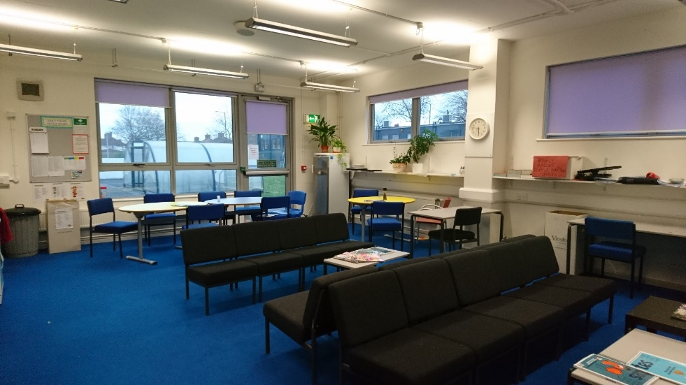
Appendix 1 - Staffroom pictures
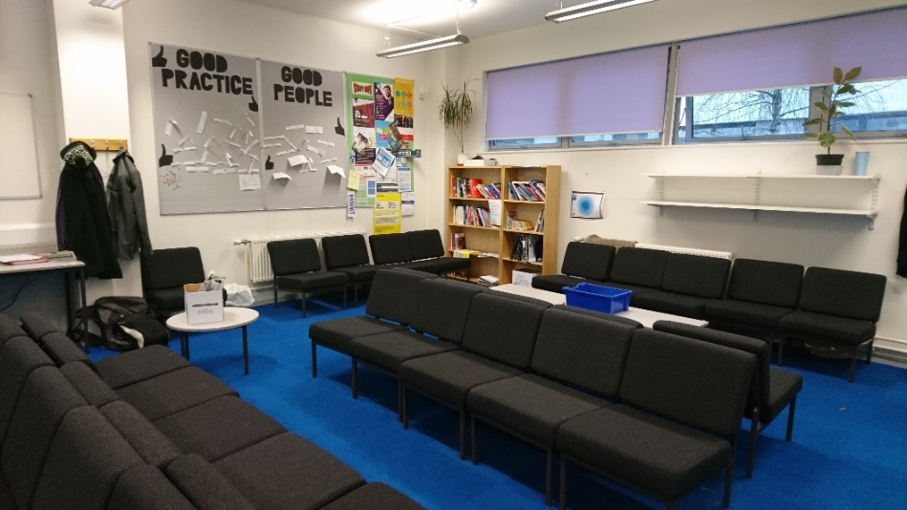
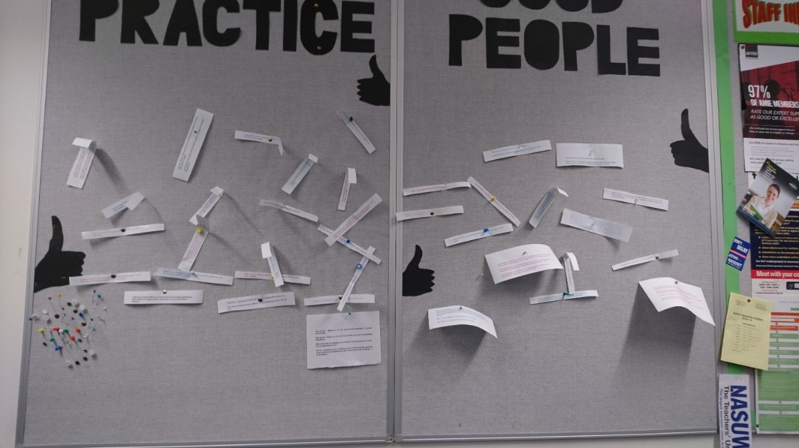
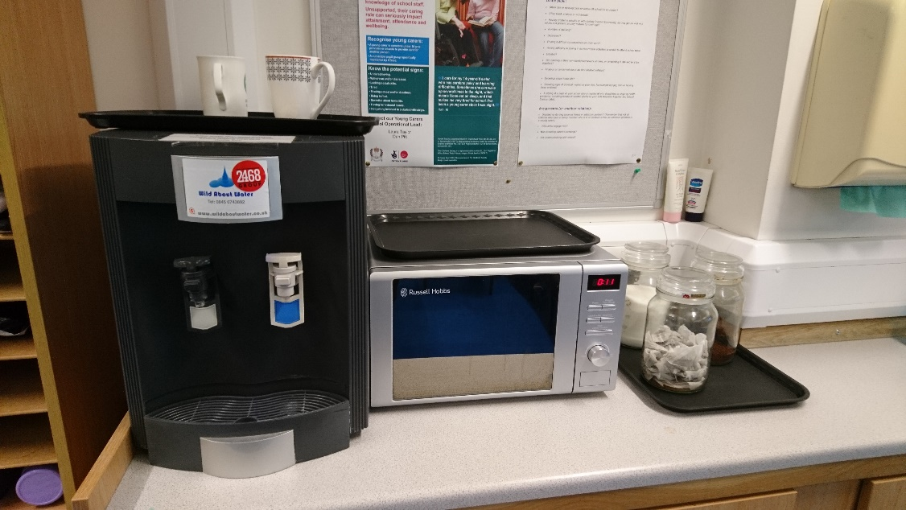
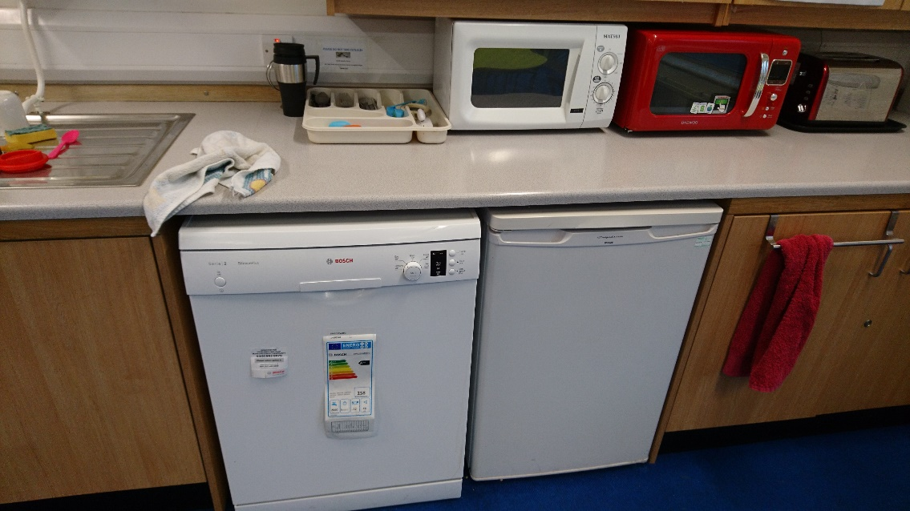

Appendix 2- CPD model
Intent
Highly effective CPD has a significant impact on student outcomes, with John Hattie’s synthesis of 800 meta-analyses putting CPD at the top of all practices analysed, with a size on pupil achievement of 0.62 (Teacher Development Trust, 2013). To achieve a highly effective CPD model, professional development at Orchard School is personalised, evidence based and needs driven. Through our role in the Chartered College of Teaching and with a research centred CPD model, we expect staff to be at the forefront of research-based pedagogy.

Implementation
Orchard School’s CPD separates professional development into core and personalised opportunities. The core CPD is designed as a direct result of outcomes whilst personalised CPD responds to the needs of all staff and aims to deepen pedagogy. The personalised CPD is linked to career progression and is based around the themes of research, teaching and learning, coaching and mentoring and leadership. The majority of core CPD is delivered in faculties and through inset sessions to ensure that we effectively respond to school wide and faculty areas for development such as differentiation, modelling, PP outcomes and the progress of boys.
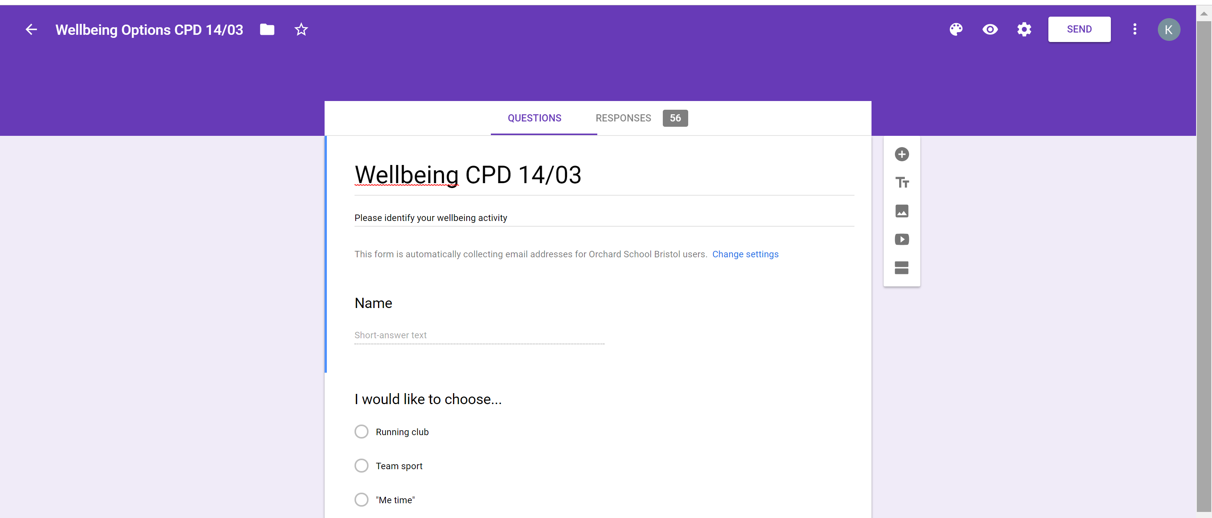

Appendix 3- Staff wellbeing
Wellbeing Charter
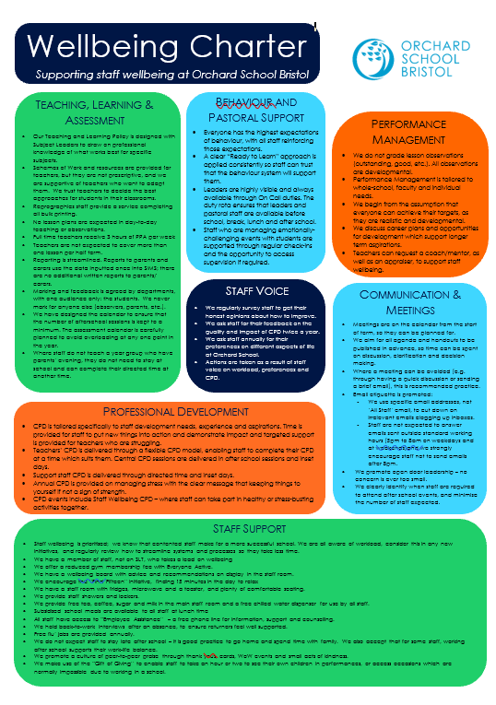
Wellbeing committee emails actions
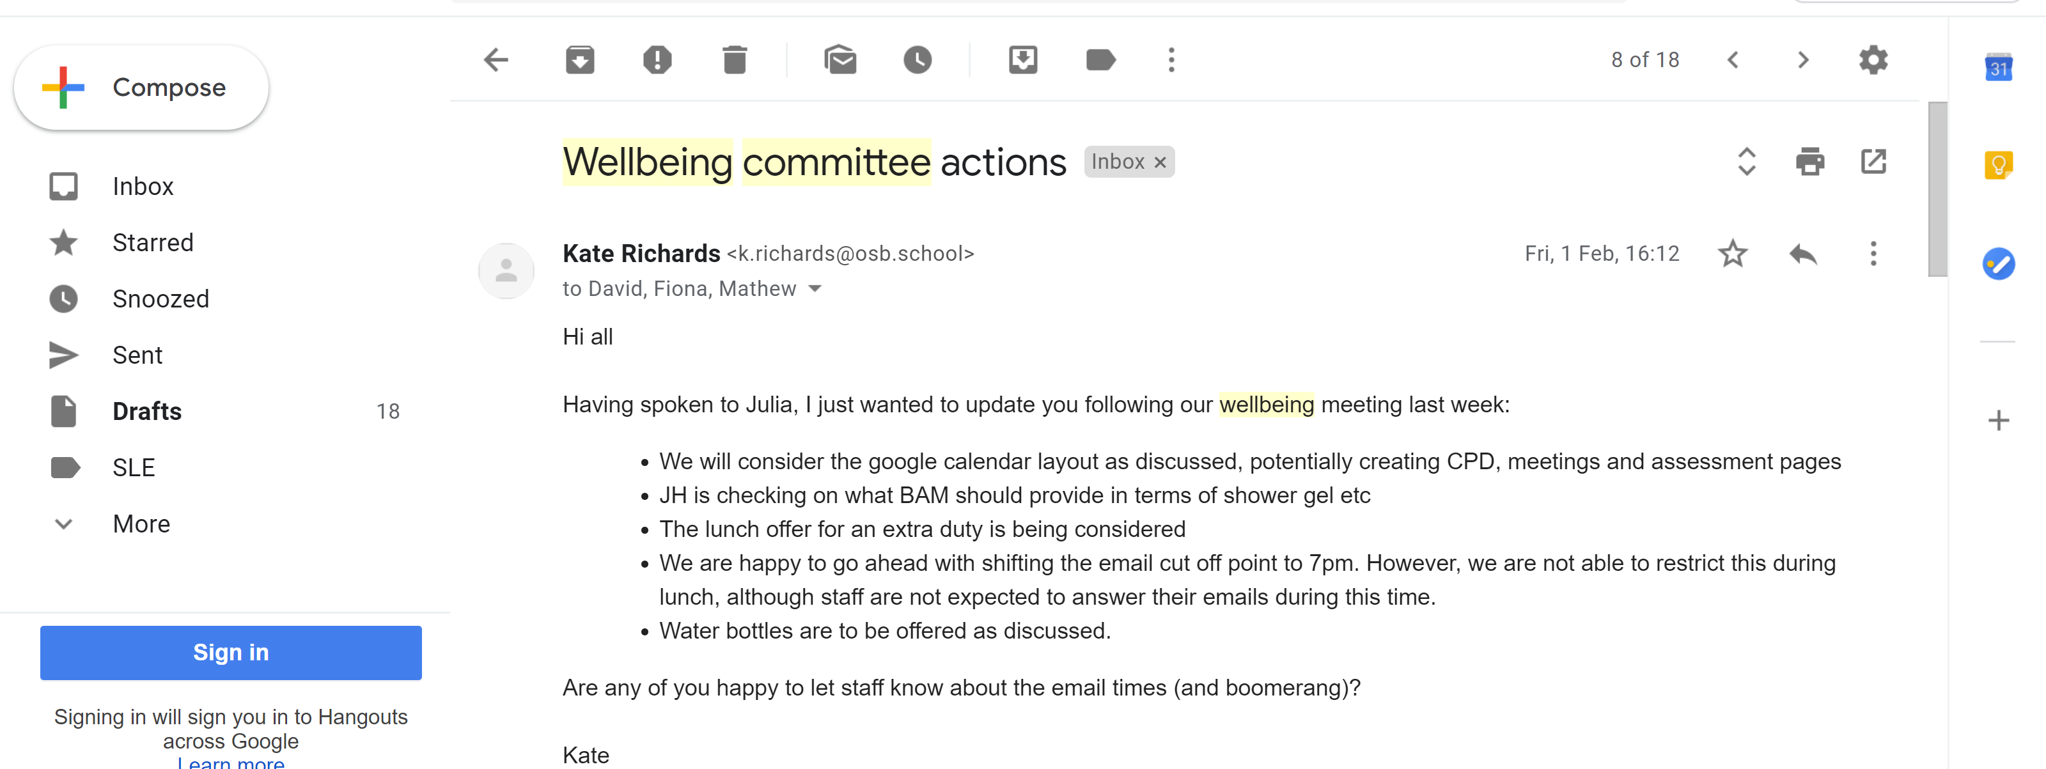

Staff Random Acts of Kindness
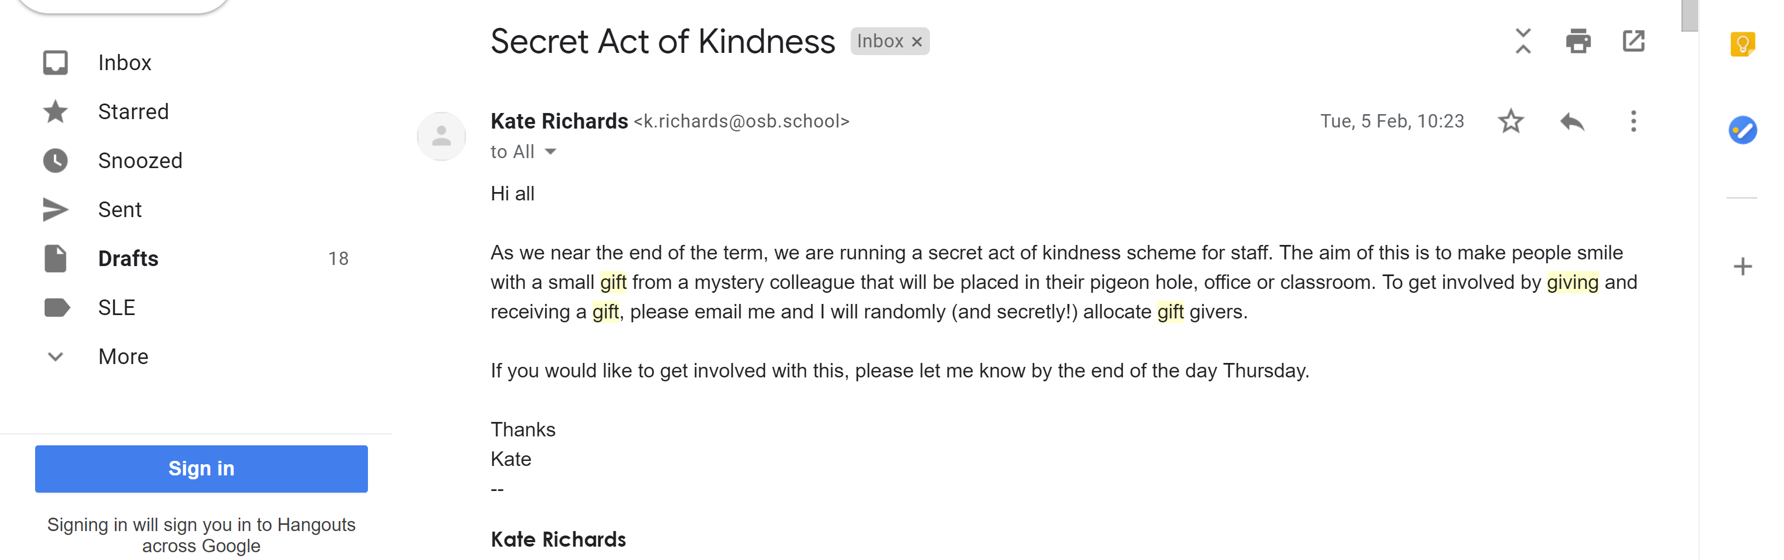
Staff RAK example- In this example, the member of staff was given a different treat, alongside these notes, each day.

An example from the second act of kindness week (May 19) and their resulting thank you email
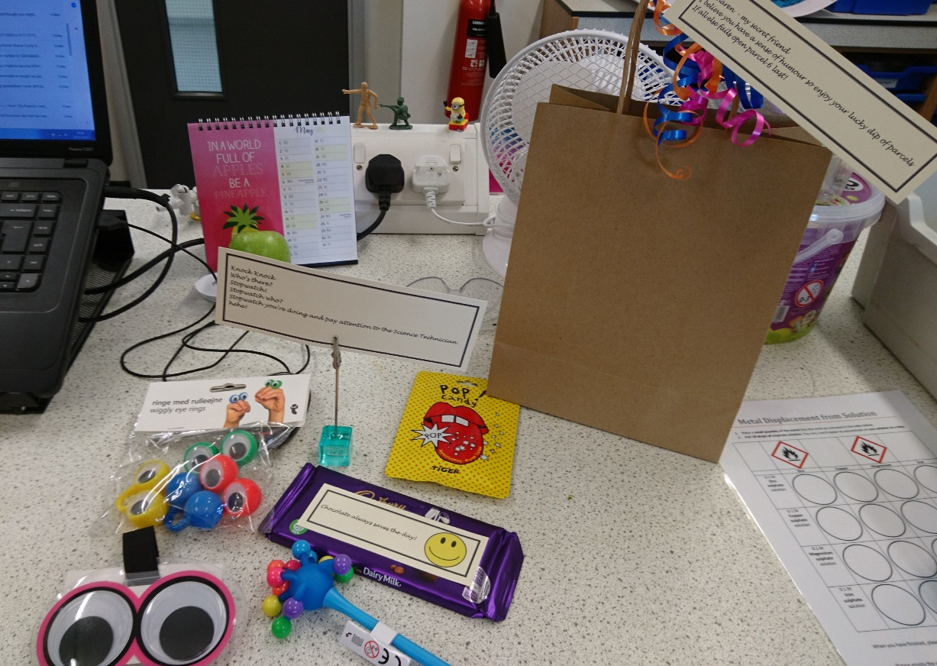

World book day

Bake off
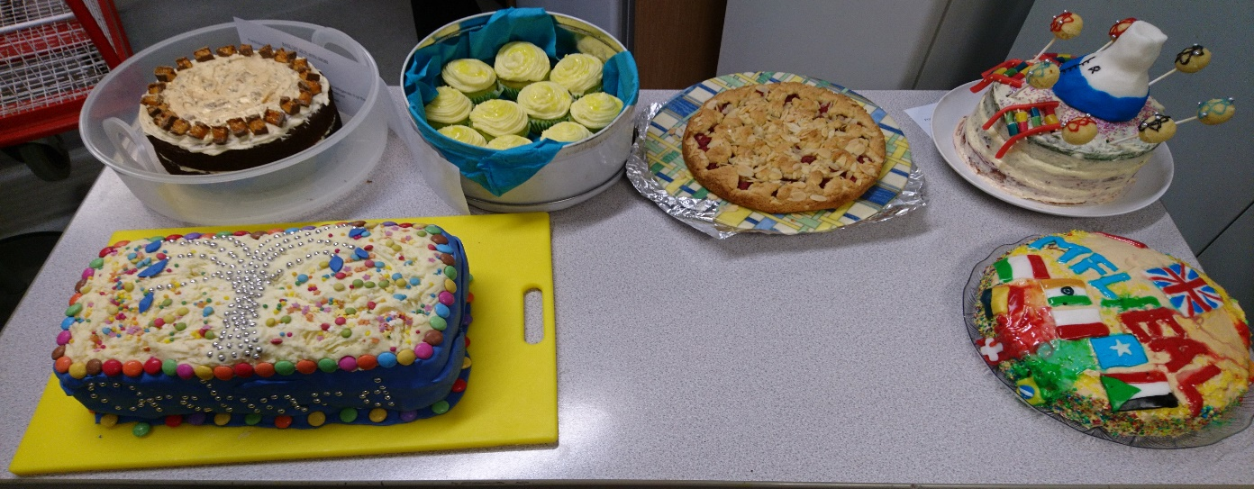
Staff thank yous WoW examples
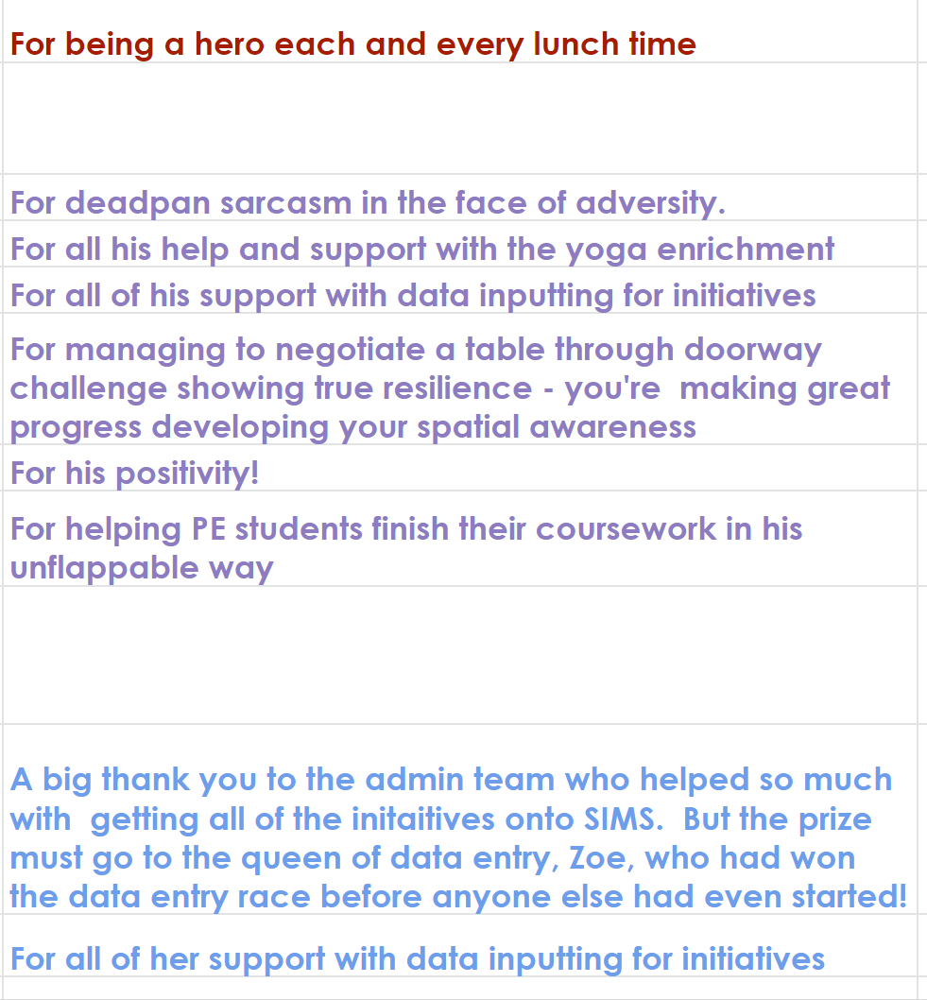

Gift of giving email
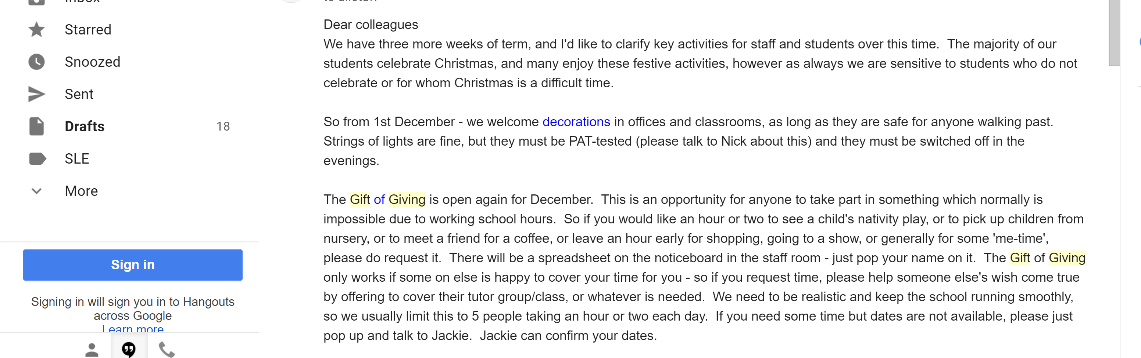
Swish
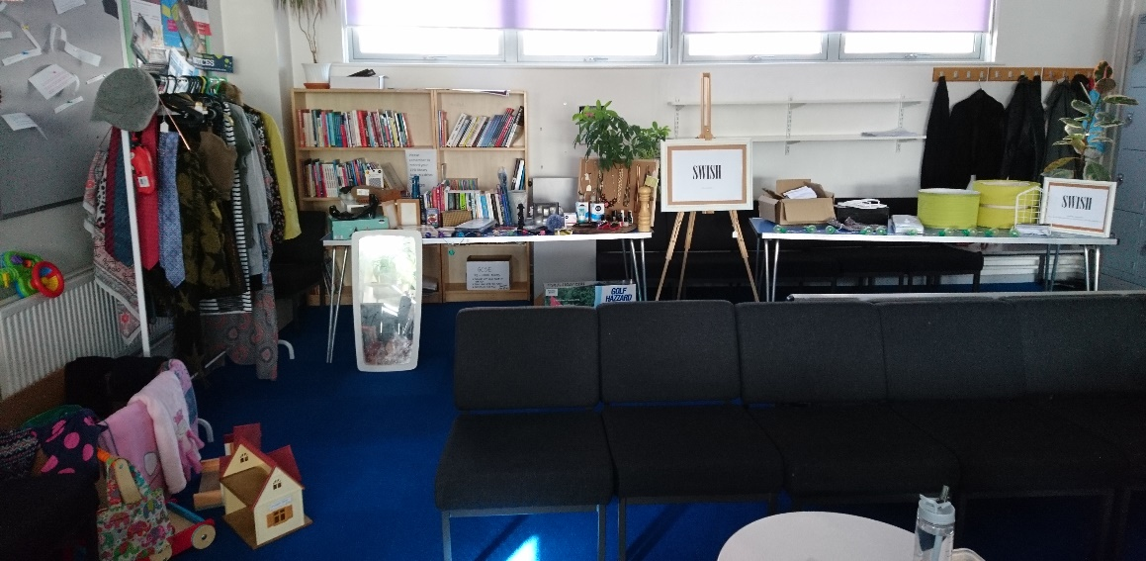

Appendix 4- Duty timetable example
Appendix 5- School Day
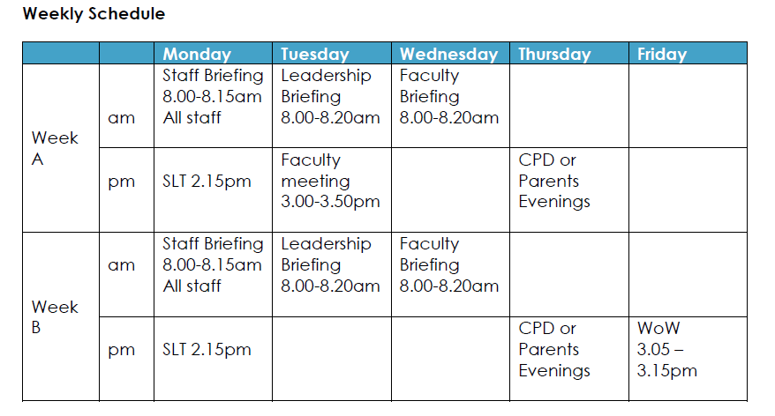
New school day
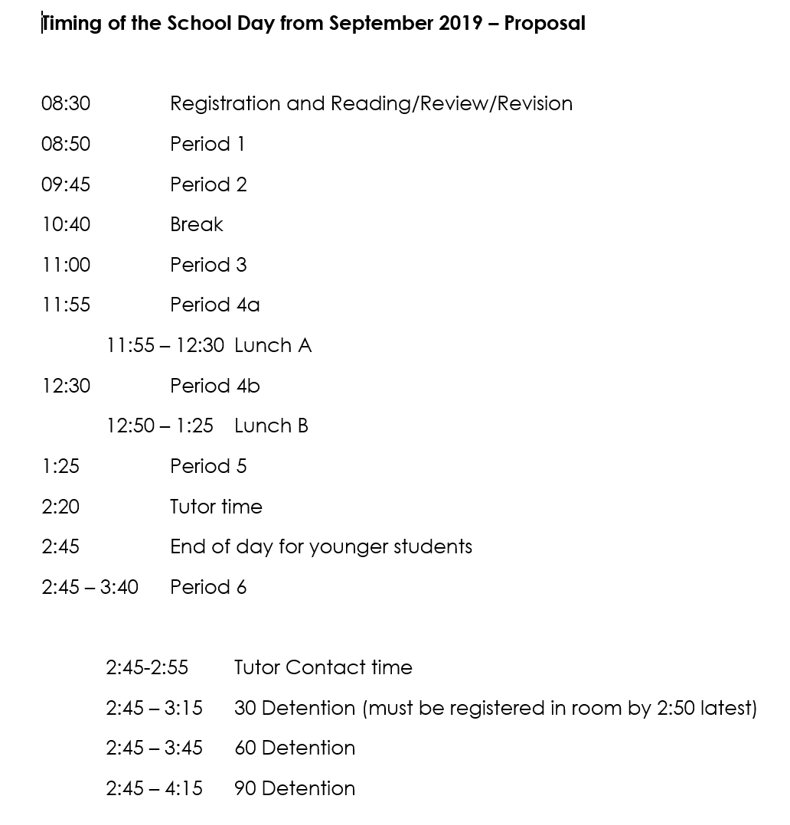
Appendix 6
June Staff Voice- completed by 58 members of staff

I feel happy at work | 7.8
My workload is appropriate to my position within the team | 7.6
I feel in control over my workload | 7.2
My workload is manageable | 7.0
I have the opportunity to succeed and progress | 7.1
The staffroom is welcoming | 7.7
I feel I have somewhere I can go for a break | 8.2
I get time to eat during the day | 7.5
I get time to drink enough during the day | 7.9
How would you rate your overall wellbeing? | 7.3
I feel well supported working in this school | 7.7
Leaders and managers are considerate of my well-being | 7.3

