Toolkit
Hilltop Primary Academy

Please decide at what level you meet the criteria and then fill in the school evidence box with as much evidence as you see fit to prove that you meet the standard. The guidance and possible evidence box is there to help you, but if you feel there are other ways you can show it then please do include them too. Reference any appendices and attach them to the email.
We have a manageable and appropriate workload
FULLY MET / PARTIALLY MET / DEVELOPING
GUIDANCE  Is appropriate PPA time given?  Are staff meetings for an appropriate amount of time?  Is time provided for leading core subjects or other areas of responsibility? | POSSIBLE EVIDENCE  Examples of release and duty timetables  Use of HLTA’s  Staff meeting timetables  Survey data | SCHOOL EVIDENCE  All teachers receive a morning or afternoon a week for PPA and each year group has a HLTA to cover PPA. Music and PE specialist teachers to cover PPA. (Appendix 1)  Management time is provided for SLT. (Appendix 2)  Weekly staff meetings planned in advance. (Appendix 3)  Scored an 8/10 for manageable workload and being in control of workload.  8/10 for an appropriate workload.  87.5% of staff agree the work they do matches their job description.  96.77% of staff feel able to do their job effectively.

We value and prioritise staff’s health and understand the need to rest and recharge.
FULLY MET / PARTIALLY MET / DEVELOPING
GUIDANCE  Do you have quality facilities for all staff to eat at lunchtimes?  - Is there enough cutlery?  - Is there enough equipment? (Microwaves, stoves etc)  - Are there appropriate tables and chairs to eat effectively?  - Are there a different choice of seats to sit on?  - Do staff get subsided school meals?  Is your staffroom welcoming?  Do you provide refreshments free of charge?  Are there enough toilet facilities for all the staff? | POSSIBLE EVIDENCE  Photographs  Staff testimonials  Staff survey data  Site plan | SCHOOL EVIDENCE  (Appendix 4) Staffroom recently decorated and reorganised.  Two microwaves and two toasters now provided.  Table and chair provided plus ‘comfy’ chairs to sit on.  Cutlery is readily available.  School meals available for £2 a day.  £10 a year for tea and coffee.  Benenden Healthcare is provided for members of staff.  Scored 7/10 for staffroom is welcoming, (before decorated and reorganised) having somewhere to go for a break and staffroom is well equipped.  Averaged 8/10 for overall wellbeing.

We have a member of staff in charge of wellbeing who is not on SLT
FULLY MET / PARTIALLY MET / DEVELOPING
GUIDANCE  Is the role set out as part of a job description?  How does the wellbeing Lead feed back to SLT? | POSSIBLE EVIDENCE  Job descriptions  Staff survey data | SCHOOL EVIDENCE  Katie Wharton is lead of wellbeing and has attended an SLT meeting to provide feedback. (Appendix 5)

Wellbeing is covered in CPD sessions 3 times a year
FULLY MET / PARTIALLY MET / DEVELOPING
GUIDANCE  Is wellbeing CPD available to all staff?  Are practical wellbeing strategies introduced?  Is health advice incorporated into CPD? | POSSIBLE EVIDENCE  Staff meeting agendas  Training timetables  Staff testimonials | SCHOOL EVIDENCE  Staff meetings provided CPD training – coaching has been introduced as a way to share work problems and help each other resolve these issues as well as offload. (Appendix 3)  Benenden HealthCare provided for full time staff – free advice, guidance and counselling is provided through this.  Staff Zumba class provided weekly.  Shout out board in the staffroom to praise individuals/groups of staff as well as provide support or guidance around wellbeing.  All staff offered a range of courses/training to attend. (Appendix 6)  Ethos of ‘tagging’ staff when they are in need of an additional break.  If a child needs to be removed from class then SLT support this with a ‘time out’ to give the teachers some respite time.  Post-crisis meetings take place to ensure staff have offloaded and have a resolution before they go home.

We operate flexible working strategies
FULLY MET / PARTIALLY MET / DEVELOPING
GUIDANCE  Is there flexible access to school during the holidays?  Does your school offer part time and job share contracts when available?  Are staff allowed (within reason) to attend their own children’s school events? | POSSIBLE EVIDENCE  Staff testimonials  Staff survey data  Staff list with days shown  School policies | SCHOOL EVIDENCE  School open 8-4 during school holidays.  Individual cases negotiated with HT  Part time staff change days of working when needed  Request forms available to attend own children’s school events etc.  Staff who are Hilltop parents are allowed to attend their child’s events

We implement the Find Fifteen Initiative
FULLY MET / PARTIALLY MET / DEVELOPING
GUIDANCE  How do you encourage staff to ‘Find Fifteen’?  How are lunch and break duties allocated to allow everyone a chance for a proper break?  Do all staff have to attend assemblies? | POSSIBLE EVIDENCE  Duty timetables  Staff testimonials | SCHOOL EVIDENCE  Break duties are shared out between teachers and TA’s so everyone has a maximum of 2 duties a week. (Appendix 7)  TA’s provided with 30 min lunch breaks.  Teachers provided with 55 min lunch breaks.  Adults only have to attend assemblies when necessary – normally twice a week.  8/10 feel they get time to eat and drink during the day.  7/10 are happy with the time they get for lunch.
Staff absence is managed effectively and is as low as possible
FULLY MET / PARTIALLY MET / DEVELOPING
GUIDANCE  What percentage of your budget is spent on supply?  Do you provide private health care?  Is there access to free advice and support?  How do you promote good health?  Does your school hold back to work interviews? | POSSIBLE EVIDENCE  Budget data  Healthcare information | SCHOOL EVIDENCE  Below expected spend on supply. HLTAs are effective at covering classes on a short term bases. Teachers feel confident that on their return disruption will be minimum  Benenden HealthCare provided for full time members of staff.  Staff board in the staffroom - information regarding well-being and counselling services are displayed.  Back to work interviews held after sickness.  Zumba class is offered weekly.  Staff feel confident to leave at the end of the day when they choose.

Our staff enjoy working at our school and are happy in their job.
FULLY MET / PARTIALLY MET / DEVELOPING
GUIDANCE  Does your staff survey reflect that?  Were there any 1-4 values ticked? How are you addressing these?  How long to staff stay (on average) at your school? | POSSIBLE EVIDENCE  Staff survey data | SCHOOL EVIDENCE  Low turnover of staff. Staff usually leave for promotion Averaged 8/10 for enjoying their job and feeling happy at work.  8/10 for staff behave positively at work and 9/10 for staff being friendly and welcoming.  100% agree they have someone they can go to for advice.  9/10 for feeling safe at school
Appendix 1 – PPA Times and Cover 2017/18
JC – Music Specialist SG – PE Specialist
YEAR | TERM 1 | TERM 2 | TERM 3 | TERM 4 | TERM 5 | TERM 6
R | THURSDAY AM  HP / FS | THURSDAY AM  HP / FS | THURSDAY AM  HP / FS | THURSDAY AM  HP / FS | THURSDAY AM  HP / FS | THURSDAY AM  HP / FS
1 | THURSDAY PM  FS / JM | THURSDAY PM  FS / JM | TUESDAY PM  JM / JC | TUESDAY PM  JM / JC | TUESDAY PM  JM / JC | TUESDAY PM  JM / JC
2 | TUESDAY PM  CF / JC | TUESDAY PM  CF / JC | THURSDAY PM  FS / CF | THURSDAY PM  FS / CF | THURSDAY PM  FS / JC | THURSDAY PM  FS / JC
3 | FRIDAY PM  MJ / JC | FRIDAY PM  MJ / JC | FRIDAY PM  MJ / JC | FRIDAY PM  MJ / JC | FRIDAY PM  MJ / JC | FRIDAY PM  MJ / SG
4 | WEDNESDAY PM  JH / SG | WEDNESDAY PM  JH / SG | THURSDAY PM  JH / JC | THURSDAY PM  JH / JC | WEDNESDAY PM  JH / JC | FRIDAY PM  JH / JC
5 | WEDNESDAY PM  CJ / JC | WEDNESDAY PM  CJ / JC | WEDNESDAY PM  CJ / SG | WEDNESDAY PM  CJ / SG | WEDNESDAY  CJ / SG | WEDNESDAY  CJ / SG
6 | THURSDAY PM  NW / JC | THURSDAY PM  NW / JC | WEDNESDAY PM  NW / JC | WEDNESDAY PM  NW / JC | TUESDAY PM  NW / SG | WEDNESDAY PM  NW / JC

Appendix 2 – Management time
Member of SLT | When | Cover
Sarah Hills | Tuesday PM | Carol Firmin
Cara Watson | Monday PM | Carol Firmin
Matt Bishop | Monday PM | Jo Hughes
Caroline Wooder | Monday PM | Nicola Woodward

Appendix 3 – Staff Meeting timetables – Highlighted are opportunities for Staff Wellbeing

Term 1
12th September Lessonbox
19th September Maths + SIP + Spinal board
26th September Coaching
3rd October No meeting – Coaching time
10th October Parents’ Evening
17th October Coaching

Term 2
31st October No Meeting – Coaching time
7th November Geography
14th November Mental Toughness
21st November Coaching
28th November Reading
5th December Writing moderation
12th December PUMA / PIRA Input
19th December No Staff meeting – mince pie eating!

Term 3
9th January Update (Lessonbox, coaching,
Academy Status)
16th January Computing
23rd January No School Staff meeting – Consortia meetings for EYFS, Literacy, SEND and Maths
30th January Working memory with EP
6th February Parents’ Evening

Term 4
20th February Attachment – Bradfields
27th February Attachment – Bradfields
6th March Coaching
13th March No Meeting
20th March Moderation
27th March Data inputting

Term 5
Staff meetings are dedicated to report writing.

Appendix 4 – Newly decorated Staffroom
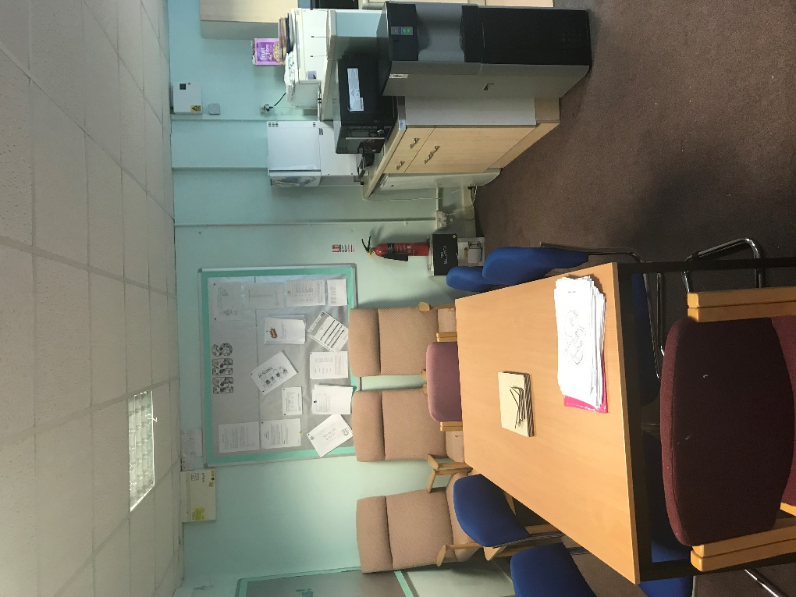
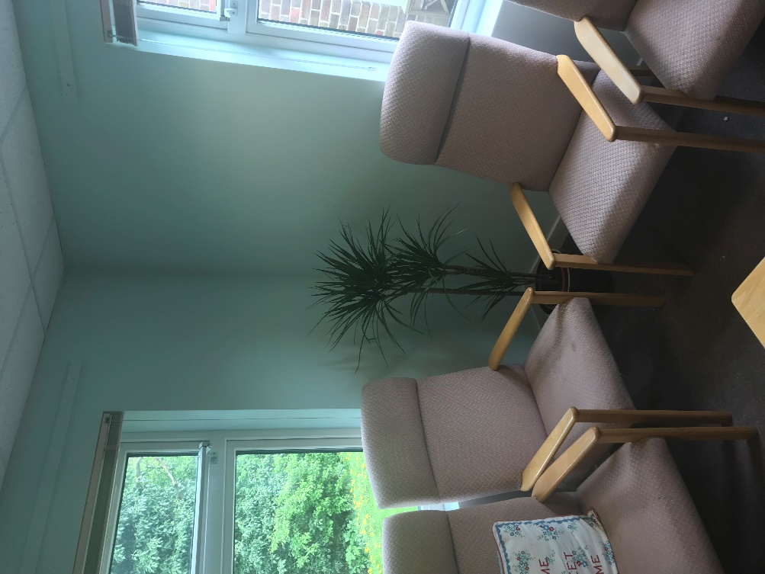
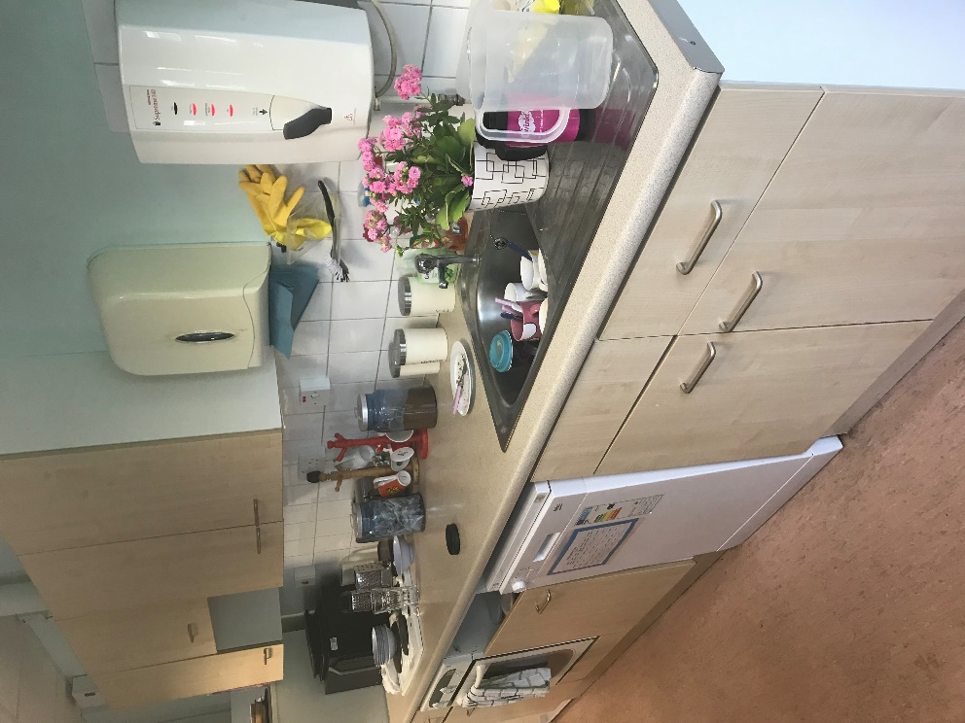

Appendix 5 – Job description of Katie Wharton – leader of child wellbeing
Additional responsibility for the Wellbeing of pupils
- Take the lead role in championing the wellbeing of pupils, ensuring your knowledge is up to date and relevant
- Act as the advocate for pupil wellbeing, maintaining a positive dialogue with other staff
- To support colleagues through offering professional advice around the wellbeing of pupils
- To provide support and challenge to the SENCo where necessary, initially through overseeing pupil support plans
- To regularly feed back to SLT and areas of strength and areas for development of the area
- To attend CPD and then share good practice with other staff through Inset and twilight sessions
- To ensure appropriate mentors are found for vulnerable pupils and a central record is kept

Appendix 6 – Opportunities for CPD training – wellbeing highlighted
Date | Member of Staff | Focus
Ongoing | Teaching Assistants | Fortnightly CPD sessions
Ongoing | Mid-Day Supervisors | Fortnightly CPD sessions
4th September | All staff | Safeguarding
18th September | Sam Presneill | Domestic Abuse
26th September | Chris Mount & Natalie Cook | Finance
26th September | All Teachers | Coaching Twilight
29th September | Kirsty Salter | Science
3rd October | Sarah Hills | Effective Writing
5th October | Emily Huxley | Lead mentor training
17th October | Lorraine Salter | Effective Grammar Teaching
17th October | All Teachers | Coaching Twilight
18th October | Cara Watson | Effective Reading
31st October | Elaine Cook | Assessment Conference
1st November | Karin Tillett | Leadership Development at Maundene
2nd November | Sarah Hills | Effective Writing
6th November | TAs | Asthma Training
16th November | Sam Presneill | Fostering Panel
17th November | Karin Tillett & Sam Presneill | Safeguarding Update
22nd November | Karin Tillett | SENCo Support Group
30th November | Nicky Woodward | Computing
4th + 5th December | Katie Wharton | Nurture Training
13th December | Caroline Wooder | Dealing with difficult people
9th January | Emily Huxley & Leanne Turner | Mentor meeting at Canterbury Christchurch
9th January | Katie Wharton | Nurture Training
10th January | Karin Tillett | SENCo support Group
11th January | Kirsty Salter | Science

As well as ‘normal’ CPD we have supported the development of our partnership with Greenacre through meetings with
Mr A Reese – CEO – weekly meetings alongside HTs of GAT schools
Mr S Radlett – Finance Manager – Conversion
Mrs N Hewitt – Admin Manager – Aligning offices and policies
Mrs S Parry – HR Manager – Wellbeing and HR
Mr T Hayes – IT Manager – Data
Mrs L Smith – Skills for Life Manager – Ethos and Skills for Life
Mrs L Ward – HT – Assessment
Mrs K Duncan – HT – Assessment
Mrs P Mayo – Senior Advisor – SEN and behaviour
Mrs S Sodhi – DHT – Behaviour
Australian students

Appendix 7 – Break duty timetables

Monday | Sarah  Jayne  Hilary
Tuesday | Ellie  Gurbakash
Wednesday | Cara  Anne  Carol
Thursday | June  Jayne B  Suzanne
Friday | Leanne  Abby  Dee

FS & KS1-

KS2 -
Key Stage Two Playground Duty 2017
 | Lower Junior | Upper Junior
Monday | Mo  Jo H | Caroline  Carly
Tuesday | Elaine  Sam | Lorraine  Suzanne
Wednesday | Emily  Keeley | Jane S  Stefan
Thursday | Kirsty  Chris | Nicky  Jane R
Friday | Matt  Jo M | Katie  Caroline

